**AN INTERNSHIP REPORT**

**ON**

**DESIGN AND ANALYSIS OF G+3 COMMERCIAL BUILDING**

*Submitted in partial fulfilment of the requirement for the award of the Degree in*

**BACHELOR OF TECHNOLOGY**

**IN**

**CIVIL ENGINEERING**

*Submitted by*

|  |  |
| --- | --- |
| **K. SAI ANAND VARDHAN** | **18501A0125** |
| **POOJITH TATINENI** | **18501A0144** |
| **R. SWAPNA** | **18501A0146** |
| **K. CHANDRASEKHAR**  **L. SRINIVASA RAO** | **18501A0123**  **18501A0127** |



**Department of CIVIL ENGINEERING**

**PRASAD V. POTLURI SIDDHARTHA INSTITUTE OF TECHNOLOGY**

**(AUTONOMOUS)**

**Affiliated to JNTU Kakinada, Approved by AICTE, New Delhi**

**Accredited by NBA & NAAC A+, ISO 9001:2015 Certified Institution**

**KANURU, VIJAYAWADA-520007**

**2021-2022**

**PRASAD V. POTLURI SIDDHARTHA INSTITUTE OF TECHNOLOGY**

**(Autonomous)**

**DEPARTMENT OF CIVIL ENGINEERING**

**KANURU, VIJAYAWADA-520007**



**CERTIFICATE**

This is to certify that the Internship work entitled “**DESIGN AND ANALYSIS OF G+3 COMMERCIAL BUILDING”** is a record of bonafide work carried out by **K. SAI ANAND VARDHAN (18501A0125), POOJITH TATINENI (18501A0144), R. SWAPNA (18501A0146), K. CHANDRASEKHAR (18501A0123), L.SRINIVASA RAO (18501A0127)** for the award of **BACHELOR OF TECHNOLOGY** degree in **CIVIL ENGINEERING** at Prasad V. Potluri Siddhartha Institute of Technology is a record of student’s work carried out under our supervision and guidance during academic year 2021-2022.

**Dr. K. RAMESH**

**Head of the Department**

**DECLARATION**

This is to certify that the Internship report entitled “**DESIGN AND ANALYSIS OF G+3 COMMERCIAL BUILDING”** written and submitted by us is an original work done is submitted in partial fulfilment of the requirements for the award of the Degree of Bachelor of Technology in Civil Engineering. This is a record of bonafide work carried out by us and the results embodied in this Internship Report have not been reproduced and copied from any source.

**PROJECT ASSOCIATES**

K. SAI ANAND VARDHAN 18501A0125

POOJITH TATINENI 18501A0144

R. SWAPNA 18501A0146

K. CHANDRASEKHAR 18501A0123

L. SRINIVASA RAO 18501A0127

**ACKNOWLEDGEMENT**

The satisfaction and euphoria on the successful completion of any task would be incomplete without the mention of the people who made it possible, whose constant guidance and encouragement crowned our effort with success.

We would like to express our profound appreciation to our Principal **Dr. K. Sivaji Babu**, **Principal, PVP Siddhartha Institute of Technology** for extending his official support for the completion of our internship.

We express our thanks to **Dr. K. Ramesh, Head of the Department**, **Civil Engineering Department** for all the facilities provided to successfully complete our internship work.

We are deeply indebted to our Internship Coordinator**, Dr. K. Shyam Prakash, Assistant Professor,** for the motivation, guidance, tutelage and patience throughout this Internship work. We appreciate his broad range of expertise and attention to detail, as well as the constant encouragement he has given to us over the years.

In our association with all the above persons, we experienced not only their depth of knowledge but also affection towards us. Finally, we take this opportunity to thank one and all of our **Civil Engineering Teaching & Non-Teaching Staff** for their able cooperation both academic and non-academic all throughout our four years. We shall remember all our staff as long as our memory lives.

**PROJECT ASSOCIATES**:

K. SAI ANAND VARDHAN 18501A0125

POOJITH TATINENI 18501A0144

R. SWAPNA 18501A0146

K. CHANDRASEKHAR 18501A0123

L. SRINIVASA RAO 18501A0127

**ABSTRACT**

Structural design is the primary aspect of civil engineering. The foremost basic in structural engineering is the design of simple basic components and members of a building viz., slabs, beams, columns and footings. In order to design them, it is important to first obtain the plan of a particular building. Thereby depending on the suitability plan layout of beams and the position of columns are fixed. A lay out plan of the proposed building is drawn by using AUTO CAD 2022. The structure consist of ground floor plus three floors. The planning is done as per Indian standard code provisions. The building frames are analysed and designed by using in Indian standard codal provisions. The structure was analysed using STAAD Pro.V8i.

**CONTENTS Page No.**

**Abstract** iii

**CHAPTERS**

**Chapter 1. INTRODUCTION**  1

**Chapter 2. GENERALTHEORY** 1

2.1 FEATURES OF STRUCTURE 1

2.2 AIM OF THE PROJECT 2

2.3 STRUCTURAL ELEMENTS 2

**Chapter 3.OBJECTIVES** 3

**Chapter 4 .LITERATURE REVIEW**  3

**Chapter 5. METHODOLOGY**

5.1 PROVIDED DATA 5

5.2 STRUCTURAL PLANNING 12

5.3 NUMBERING AND NOMENCLATURE 12

5.4 SIZING OF BEAMS, COLUMNS AND SLABS 12

**Chapter 6. DESIGN OF FOOTING** 14

6.1 DESIGN PARAMETERS 14

**Chapter 7. SUMMARY OF AXIAL FORCES, SHEAR, TORSION,**

**BENDING MOMENTS IN BEAMS AND COLUMN** 20

**Chapter 8. REINFORCEMENT IN COLUMNS AND BEAMS** 21

**Chapter 9. VOLUME OF CONCRETE AND STEEL IN SUPERSTRUCTURE** 22

**Chapter 10. DESIGN OF STAIR CASE** 22

**Chapter11. CONCLUSION**  23

**Chapter 12. REFERENCES** 24

**CARPET AREA OF THE BUILDING** 25

**LIST OF FIGURES Page No.**

5(a). PLAN 6

5(b). ELEVATION 7

5(c). GROUND FLOOR PLAN 8

5(d). STRUCTURAL PLAN 9

5(e). SKELETAL VIEW 10

5(f). 3D RENDERED 11

6(a). Footing Geometry 15

6(b). Cover & Soil 15

6(c). Concrete & Rebar 15

6(d). Sliding & Overturning 16

6(e). Foundation Layout 17

6(f) Foundation GA Drawing 17

6(g). Foundation Elevation Actual Fig. 18

6(h). Foundation Plan Actual Fig. 18

6(i). Schematic Elevation of Footing 19

6(j). Schematic Plan of Footing 19

8(a). Beam Design 21

8(b). Column Design 21

9(a). Total volume of concrete 22

10. Design of stair case 23

**LIST OF TABLES Page No.**

6(a). Geometry of Foundation15

6(b). Reinforcement of Footing16

7(a) Axial Forces, Shear, Torsion, Bending Moments 20

**DESIGN AND ANALYSIS OF G+3 COMMERCIAL BUILDING**

**KEYWORDS:** Commercial Building, AutoCAD 2022, STAAD Pro. V8i.

**1. INTRODUCTION:**

STAAD-PRO is a structural analysis design software, it includes a state-of-the-art user interface, visualization tools and international design codes. It is used 3D models generation, analysis and multi material design, the commercial version of STAAD PRO supports several steel, concrete and timber design codes, it is the software application created to help structural engineer to automate their task and remove the tedious and long procedure of the manual calculation for designing method. In this project there is a commercial building G+3.

A structure refers to a system of two or more connected parts used to support a load. It is an assemble of two or more basic components connected to each other so that they serve the user and carry the loads developing due to the self and super imposed loads safely without causing any serviceability failure. The whole structural and its loading conditions might be of complex nature so as to make it simpler, we use certain simplifying assumptions related to the quality of the material, member geometry, nature of applied loads their distribution, type of

Connections at the joints and support conditions.

**2. GENERAL THEORY:**

Now-a-days high rise buildings and multi-storeyed buildings are very common in metropolitan cities. The analysis of frames of multi-storeyed buildings proves to be rather cumbersome as the frames have large number of joints which are free to move. The loadings are supposed to be taken from respective design codes and local specifications, if any. The forces in the members and the displacements of the joints are found using the theory of structural analysis.

**2.1 FEATURES OF STRUCTURE:**

* Framed R.C.C structure
* Materials used**:**
* Cement: 43 grade (used for brickwork and plastering).

53 grade (used for R.C.C works).

* Concrete: M20 grade for R.C.C.
* Steel: HYSD TMT rods.
* Brick: 1st class bricks (19cm ×9cm × 9cm).
* Type of flooring: VCT- Vinyl Composite Tile flooring.

**2.2 AIM OF THE PROJECT:**

Carrying out a complete analysis and design of the main structural elements of a multi-storey building including slabs, columns.

1. Getting familiar with structural soft wares

(STAAD pro, STAAD Foundation, AutoCAD)

1. Designs will be as per following codes:
2. Indian standard plain and reinforced concrete code of practice. IS 456:2000
3. IS:875 code of practice for design loads.

**Computer aided design of residential building by using STAAD PRO which includes-**

**❖ Generating structural framing plan**

**❖ Getting model**

**❖ Analysis of structure**

**❖ Design of structure**

**2.3 STRUCTURAL ELEMENTS:**

Each building structure consists of the following elements:

**Slabs:** Horizontal plate elements carrying the loads.

**Beams:** Horizontal members carrying the load from slabs.

**Columns:** Vertical members carrying mainly axial loads (interior columns) but sometimes they carry axial loads and moments in the case of exterior beams.

**Walls**: Vertical plate elements resisting vertical, lateral or in-plane loads.

**Bases and foundations:** Directly supported by the soil, they help to distribute the loads, transferred by the elements above, and on a larger area thus reducing the stresses applied to the soil.

**3. OBJECTIVES:**

The objectives of the project are mentioned below:

1. Draft the Layout of the proposed Commercial building using AutoCAD 2022.

2. Analyse and Design the building on STAAD Pro V8i.

3. Plan the project schedule.

4. Analysis include footing, columns, beams, slabs, and staircase and lift design.

**4. LITERATURE REVIEW:**

**DINESH RANJAN. S, AISHWARYALAKSHMI.V (2017): -**

In this paper the author concluded that Institutional Building designed by using of STAAD PRO 2007. Using of this software analysis of bending moment, shear force, deflections, end moments and foundation reactions are calculated. Detailed drawings of all R.C.C. members such as slabs, beams, columns, and footings. The author concluded that in developing countries like India, cities are growing very fast, and the institution plays a major role in the development of nation’s economy. This made us to think about this and we decided to go with it.

**PROPOSED CONSTRUCTION OF PUBLIC BUILDING (G+2) AT, PUDUCHERRY: -**

These private company designed a good infrastructure institutional building with details where the load cases and the effects and two 2D plans .and analysis of data by using the STAAD Pro software by merging into it. They taken the soil samples even and done the process and designed as per the client review and made a made a building for 500 students in the G+2 structure.

**BUILDING DESIGN AND CONSTRUCTION HANDBOOK: -**

Recommendations for basic requirements of commercial buildings here we can take the reference values of the sizes, loads and the inner lengths and the wall thickness and properties of the construction material and their behaviour in different environmental conditions showcasing the necessity of preferability.

**BYJU SUBHASH S, DEEPU R (2013**): -

This paper is on Analysis and Design of Multi-Storeyed Building using STAAD PRO.

The major function of substructure is to transmit load from the superstructure uniformly and safely to the strata of soil below it. The type of foundation to be adopted and designed depends on the nature of the load and the supporting soil. =The various loads acting on the structure are obtained according to the IS codes and are calculated during load calculation. The soil characteristics required for foundation design-angle of internal friction, standard penetration number, position of water table, and the depth of the refusal stratum, are obtained from Soil investigation report from the proposed site

The aim of this project work is to analyse a 5-storeyed hostel building for different load combinations using STAAD Pro software. Based on the analysis, design of the structure is done mainly in accordance with IS specifications.

The typical design of commercial building with s presented in this handbook is based on analytical approach.

**Richard C. Hunter, Ed.D (2009):-**

Our nation must take major steps now to address the school infrastructure problem before it worsens. Clearly, it is easier to defer maintenance and to put these problems off for future generations. In Kansas City, this was the case until the judge issued his order, whereas in Richmond the community acted before its school facilities deteriorated. I recommend the latter course.

**CODE BOOKS:**

IS456-2000, FOR DESIGN OF CONCRETE STRUCTURES

SP-16, FOR DESIGN OF COLUMNS

IS875-FOR LOADS

* Part-1(1984): for dead loads
* Part-2(1984): for live loads
* Part-3(2015): for wind loads
* Part-4(1984): for snow loads
* Part-5(1984): for combination of loads

IS13920-2016: ductile detailing of R.C.C.

NBC-2016 volume-1&2

Andhra Pradesh building rules-G.OM.S 119(2017).

**5. METHODOLOGY:**

The materials and software’s used in this project is.

1. AUTOCAD 2022:

To design the educational building plan.

2. STAAD PRO V8i:

To analyse the building plan designed in the AutoCAD.

**5.1 PROVIDED DATA:**

Type of construction: RCC Structure

No of stories: 4

Types of walls: Brick wall

Floor to floor height: 3.1m

External Walls: 300mm thick

Internal Walls: 150mm thick

Loads: Live Load = 4 KN/m2

Dead Loads,

Self-Weight = Specific Weight of concrete X Volume of concrete

Floor Finish = 1.0 kN/m2

Wind Loads = 0.9 to 1 kN/m2 up to 13.05m height.

Materials: Concrete grade: M20

Unit Weight of Concrete = 25 kN/m2

Steel grades: HYSD bars of Fe415 grade

Bearing capacity of soil: 200 N/mm2

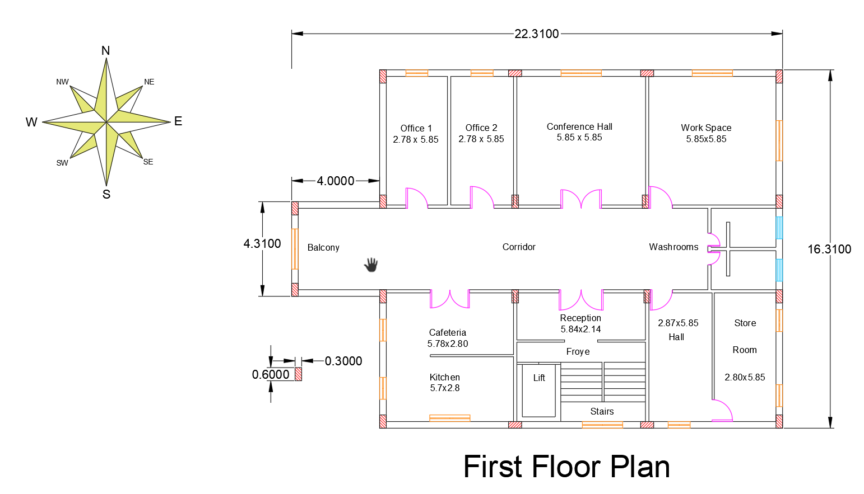

Figure 5(a). **PLAN**

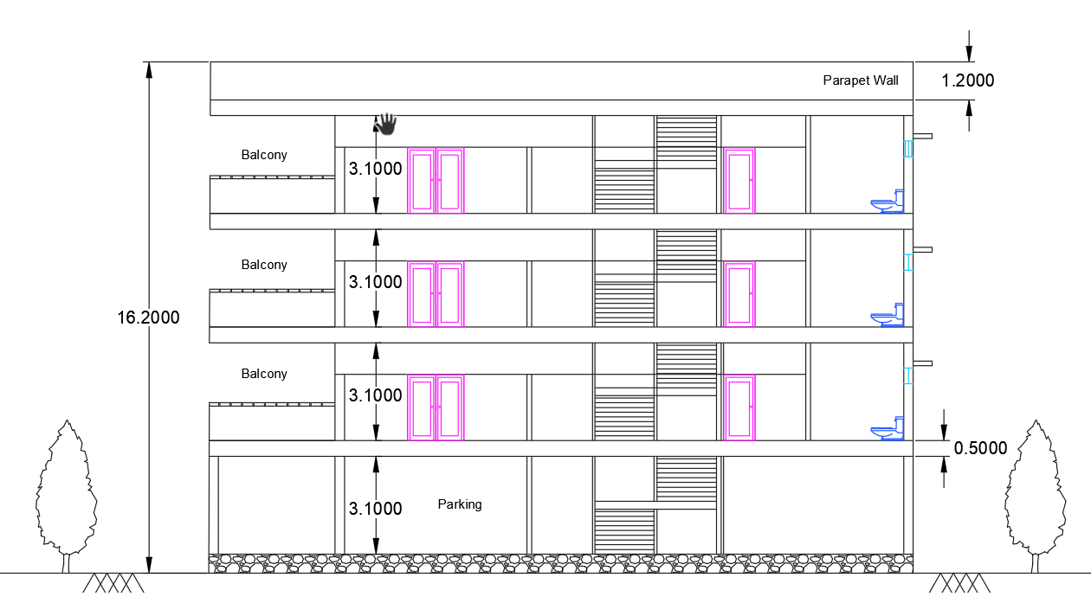

Figure 5(b). **ELEVATION**

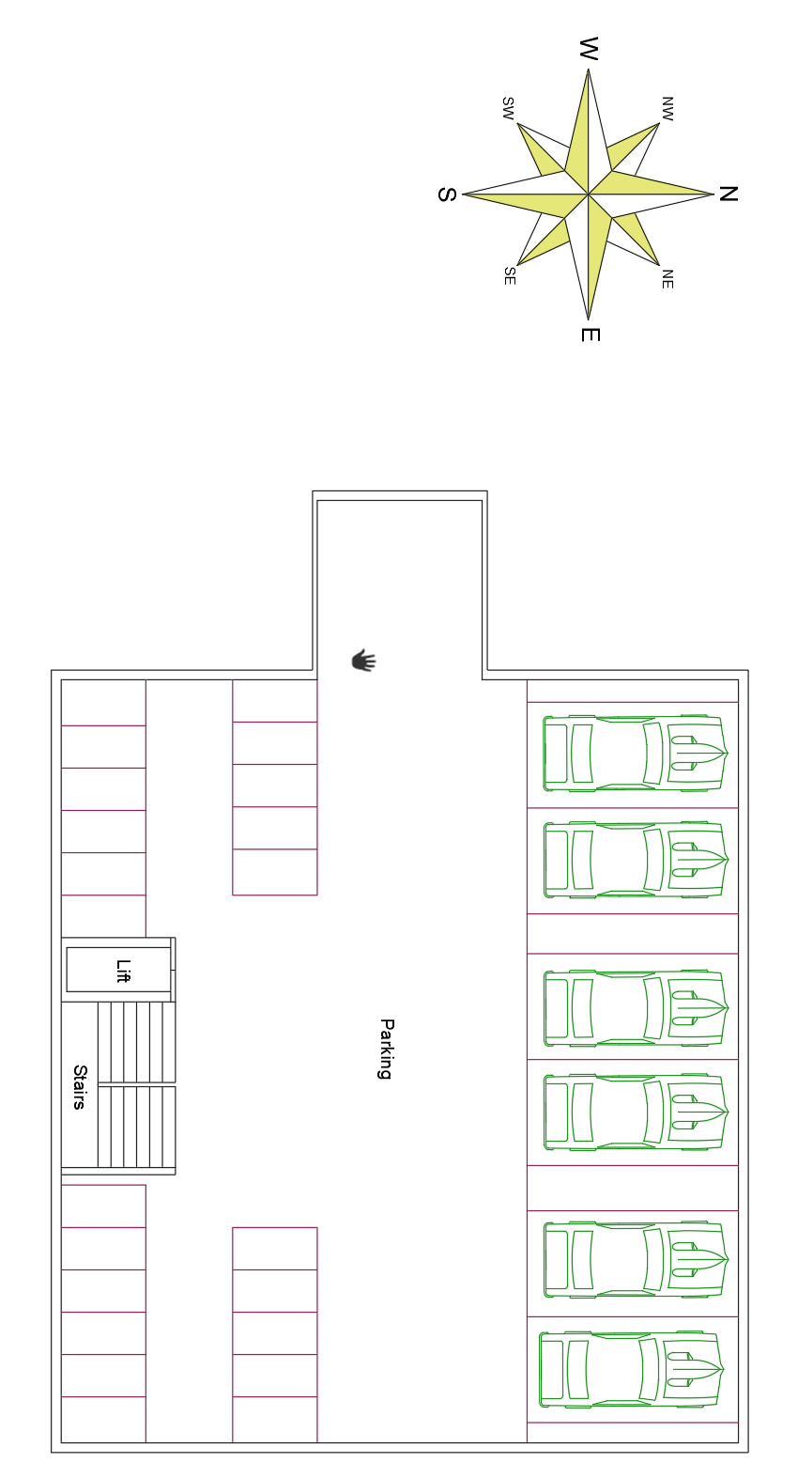

Figure 5(c). **GROUND FLOOR PLAN**

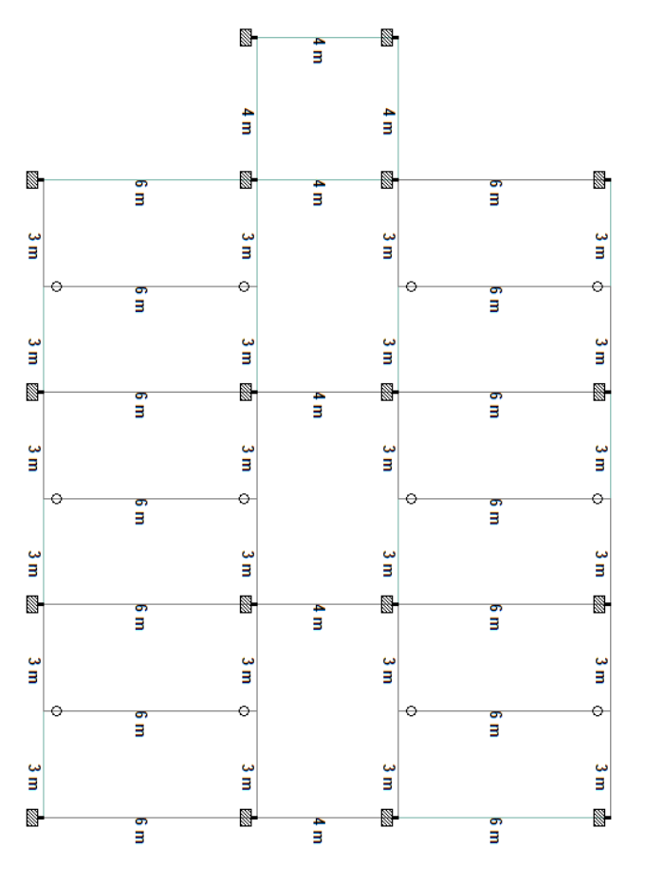

Figure 5(d). **STRUCTURAL PLAN**

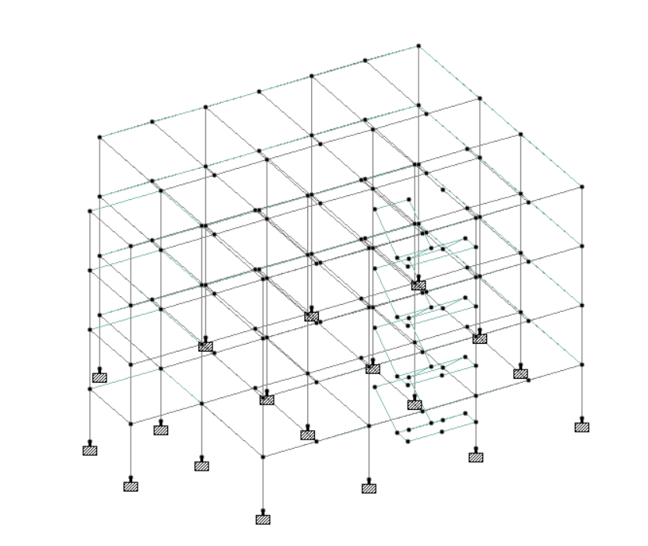

sFigure 5(e). **SKELETAL VIEW**

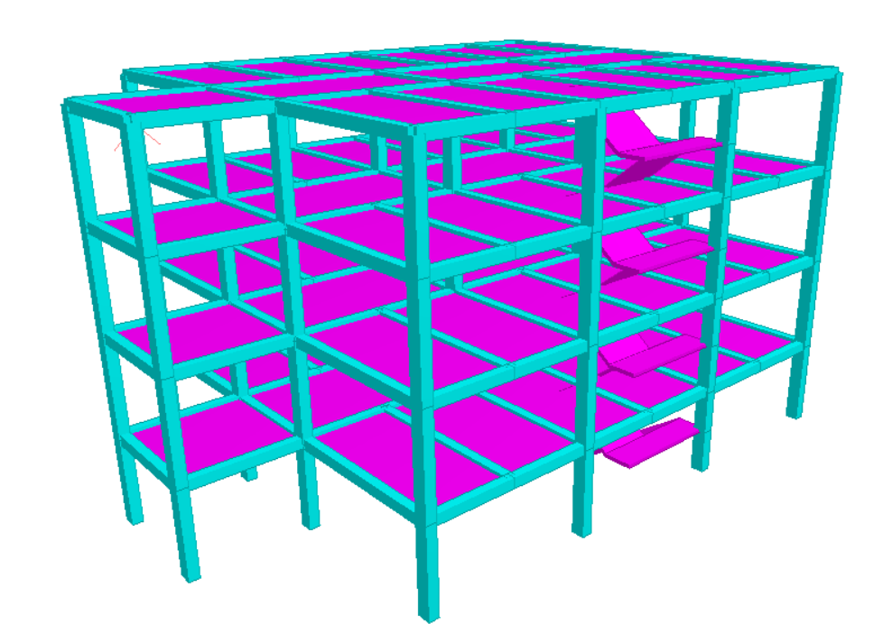

Figure 5(f). **3D RENDERED VIEW**

**5.2 STRUCTURAL PLANNING:**

The work of designer starts with planning of structural members from the given architectural plan. It commences with deciding positions of columns, followed by positioning of beams and spanning of slabs. This can be done by using guiding principles. Once the positions of columns and walls are decided, most of the locations of beams get automatically fixed from position of column and wall

**5.3 NUMBERING AND NOMENCLATURE:**

The building has symmetry in both the directions as far as the layout of room is concerned. Therefore, the numbering of slabs and beams is done for one quadrant and central stair corridor only. Columns are, however, numbered serially starting from left corner and proceeding rightward and then downwards to facilitate setting out of building. Due to symmetry, the design of members is required to facilitate setting out of the building. Due to symmetry, the design of members is required to be done for one flat and stair portion only. With the addition of a 125mm slab thickness.

**5.4 SIZING OF BEAMS, COLUMNS AND SLABS:**

**5.4.1 Beam**

There are three types of reinforced concrete beams

• **Single Reinforced Beams:**

In singly reinforced simply supported beams steel bars are placed near the bottom of the beam where they are effective in resisting in the tensile bending stress.

**• Double Reinforced Beams:**

It is reinforced under compression tension regions. The necessities of steel of compression region arise due to two reasons. When depth of beam is restricted. The strength availability singly reinforced beam is in adequate.

**Beam depth to width ratio**: - as per IS – 13920  
the width to depth ratio should be more than 0.3 (width/depth > 0.3).

**Beam depth to span ratio**: - Calculation of minimum size of RCC beam as per IS 456 2000, for cantilever beam span to effective depth of beam ratio is 7, 20 for simply supported beam and 26 for continuous beam.

**Beam depth formula: -** beam is various type like cantilever beam, simply supported beam and continuous beam. Calculation of minimum size of RCC beam as per IS 456 2000, Beam depth formula for cantilever beam is L/7 (span to effective depth of beam ratio is 7), L/20 for simply supported beam and L/26 for continuous beam.

**Beam depth for 6m span: -** according to general Thumb Rule for residential building, beam depth for 6m span should be 350mm, minimum beam size for 6m span is 10″×14″ (250mm × 350mm) in which depth of beam is 350mm and width is 250mm

For given span of beam = 6m = 6000mm, beam depth for simply supported beam is L/20, effective depth should be

6000/20 =300 mm

Overall Depth = 300 +16/2+25 = 333mm,

it should be taken depth as 350mm,

Width = 350/1.5= 233mm

Which is taken as 10″ (250mm), so beam size for 6m span is 10″×14″ (250mm × 350mm) in which depth of beam is 350mm and width is 250mm.

* ***Provided size of Beam, 0.35m x 0.3m***

**5.4.2 Column**

A column may be defined as an element used primary to support axial compressive loads and with a height of a least three times its lateral dimension. The strength of column depends upon the strength of materials, shape and size of cross section, length and degree of proportional and dedicational restrains at its ends.

The size of the columns depends on the total load on the columns. The minimum column size should not be less than 9 "x9" or 0.23m x 0.23m.

* ***Provided size of Beam, 0.35m x 0.45m***

**5.4.3 Slab Thickness**

Slabs are most widely used structural elements forming floor and roof of building. Slab support mainly transverse load and transfer them to supports by bending actions more or one direction. On the basis of spanning direction: It is two type one-way slabs and two-way slab.

Concrete is generally applied with a thickness of 2 inches or more, but the thicker it is, the stronger the slab will be. Four (150mm) inches is more common for a slab.

* ***Provided Thickness of Slab, 0.15m.***

**6. DESIGN OF FOOTING:**

**6.1 Footing**:

Foundations are structural elements that transfer loads from the building or individual column to the earth. If these loads are to be properly transmitted, foundations must be designed to prevent excessive settlement or rotation, to minimize differential settlement and to provide adequate safety against sliding and overturning

Categorization of Footings: All footings have been designed as Isolated Footings for axial loads assuming pinned support as the bearing capacity of the soil is reasonably low.

After the superstructure, the substructure design is carried out to make a comparison of design result for gravity load case the material used are same as before. For this purpose, design data are exported to STAAD foundation from STAAD-pro. The analysis and design are carried out using Indian code and a representative data.

Footing dimension given by STAAD foundation is more than manual design and reinforcement spacing also get reduced in STAAD foundation.

* No. of footings = 18.
* Depth of footing beneath G.L. = 1.83m

**6.2 DESIGN PARAMETERS:**

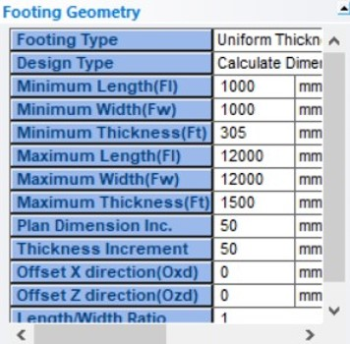 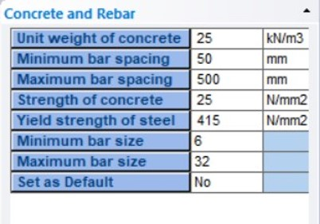

Figure 6(a). Footing Geometry Figure 6(c). Concrete & Rebar

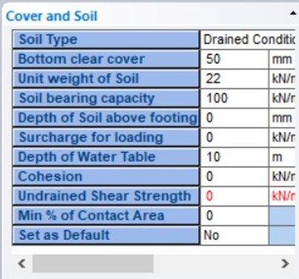 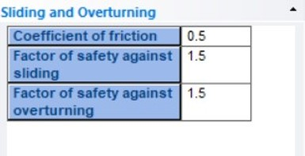

Figure 6(b). Cover & Soil Figure 6(d). Sliding & Overturning

|  |  |  |  |
| --- | --- | --- | --- |
| Footing No. | Foundation Geometry | | |
| - | Length | Width | Thickness |
| 32 | 3.500 m | 3.500 m | 0.406 m |
| 33 | 1.900 m | 1.900 m | 0.305 m |
| 34 | 1.900 m | 1.900 m | 0.305 m |
| 35 | 3.500 m | 3.500 m | 0.406 m |
| 36 | 1.950 m | 1.950 m | 0.305 m |
| 37 | 2.350 m | 2.350 m | 0.305 m |
| 38 | 2.350 m | 2.350 m | 0.305 m |
| 39 | 1.800 m | 1.800 m | 0.305 m |
| 40 | 1.950 m | 1.950 m | 0.305 m |
| 41 | 2.350 m | 2.350 m | 0.305 m |
| 42 | 2.350 m | 2.350 m | 0.305 m |
| 43 | 1.800 m | 1.800 m | 0.305 m |
| 44 | 3.500 m | 3.500 m | 0.406 m |
| 45 | 1.900 m | 1.900 m | 0.305 m |
| 46 | 1.900 m | 1.900 m | 0.305 m |
| 47 | 3.500 m | 3.500 m | 0.406 m |
| 173 | 1.300 m | 1.300 m | 0.305 m |
| 174 | 1.300 m | 1.300 m | 0.305 m |

Table 6(a). Geometry of Foundation

|  |  |  |  |  |
| --- | --- | --- | --- | --- |
| Footing No. | Footing Reinforcement | | | |
| - | Bottom Reinforcement(Mz) | Bottom Reinforcement(Mx) | Top Reinforcement(Mz) | Top Reinforcement(Mx) |
| 32 | Ø8 @ 50 mm c/c | Ø8 @ 55 mm c/c | Ø6 @ 75 mm c/c | Ø6 @ 75 mm c/c |
|  |  |  |  |  |
| 33 | Ø6 @ 70 mm c/c | Ø6 @ 70 mm c/c | Ø6 @ 70 mm c/c | Ø6 @ 70 mm c/c |
| 34 | Ø6 @ 70 mm c/c | Ø6 @ 70 mm c/c | Ø6 @ 70 mm c/c | Ø6 @ 70 mm c/c |
| 35 | Ø8 @ 50 mm c/c | Ø8 @ 55 mm c/c | Ø6 @ 75 mm c/c | Ø6 @ 75 mm c/c |
| 36 | Ø6 @ 70 mm c/c | Ø6 @ 70 mm c/c | Ø6 @ 70 mm c/c | Ø6 @ 70 mm c/c |
| 37 | Ø6 @ 50 mm c/c | Ø6 @ 60 mm c/c | Ø6 @ 70 mm c/c | Ø6 @ 70 mm c/c |
| 38 | Ø6 @ 50 mm c/c | Ø6 @ 60 mm c/c | Ø6 @ 70 mm c/c | Ø6 @ 70 mm c/c |
| 39 | Ø6 @ 70 mm c/c | Ø6 @ 70 mm c/c | Ø6 @ 70 mm c/c | Ø6 @ 70 mm c/c |
| 40 | Ø6 @ 70 mm c/c | Ø6 @ 70 mm c/c | Ø6 @ 70 mm c/c | Ø6 @ 70 mm c/c |
| 41 | Ø6 @ 50 mm c/c | Ø6 @ 60 mm c/c | Ø6 @ 70 mm c/c | Ø6 @ 70 mm c/c |
| 42 | Ø6 @ 50 mm c/c | Ø6 @ 60 mm c/c | Ø6 @ 70 mm c/c | Ø6 @ 70 mm c/c |
| 43 | Ø6 @ 70 mm c/c | Ø6 @ 70 mm c/c | Ø6 @ 70 mm c/c | Ø6 @ 70 mm c/c |
| 44 | Ø8 @ 50 mm c/c | Ø8 @ 55 mm c/c | Ø6 @ 75 mm c/c | Ø6 @ 75 mm c/c |
| 45 | Ø6 @ 70 mm c/c | Ø6 @ 70 mm c/c | Ø6 @ 70 mm c/c | Ø6 @ 70 mm c/c |
| 46 | Ø6 @ 70 mm c/c | Ø6 @ 70 mm c/c | Ø6 @ 70 mm c/c | Ø6 @ 70 mm c/c |
| 47 | Ø8 @ 50 mm c/c | Ø8 @ 55 mm c/c | Ø6 @ 75 mm c/c | Ø6 @ 75 mm c/c |
| 173 | Ø6 @ 70 mm c/c | Ø6 @ 70 mm c/c | Ø6 @ 70 mm c/c | Ø6 @ 70 mm c/c |
| 174 | Ø6 @ 70 mm c/c | Ø6 @ 70 mm c/c | Ø6 @ 70 mm c/c | Ø6 @ 70 mm c/c |

Table 6(b). Reinforcement of Footing

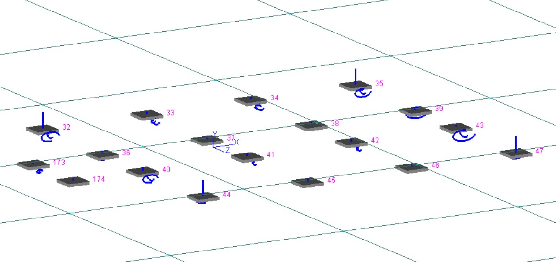

Figure 6(e). Foundation Layout

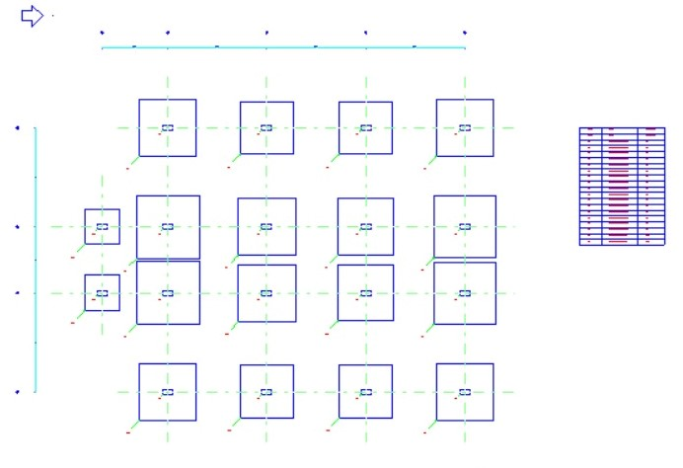

Figure 6(f). Foundation GA Drawing

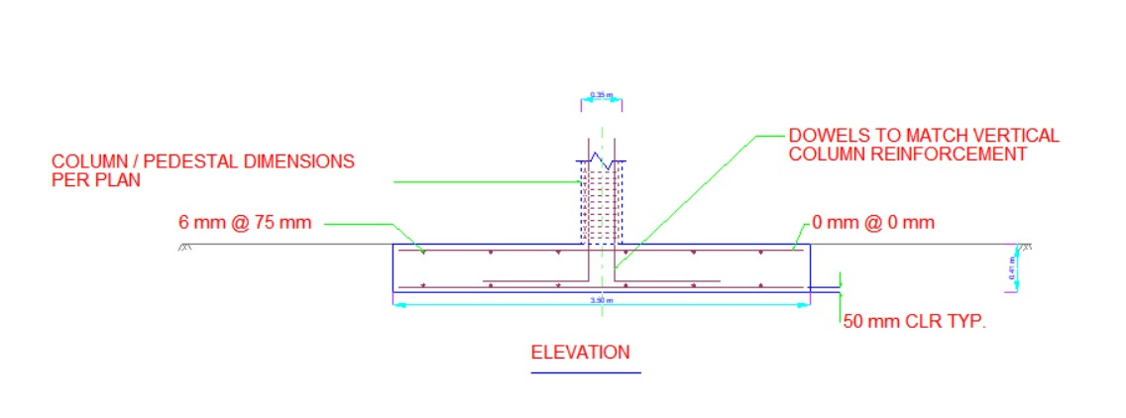

Figure 6(g). Foundation Elevation Actual Fig.

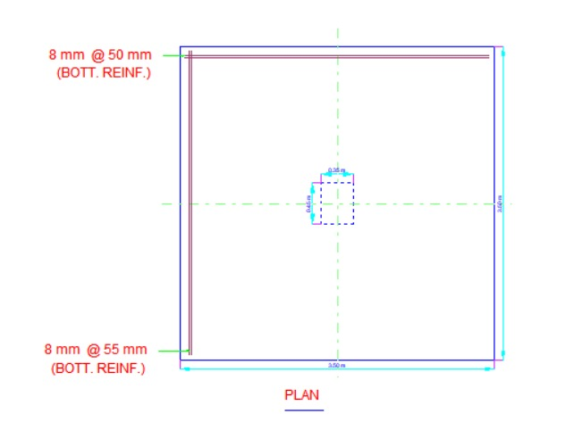

Figure 6(h). Foundation Plan Actual Fig.

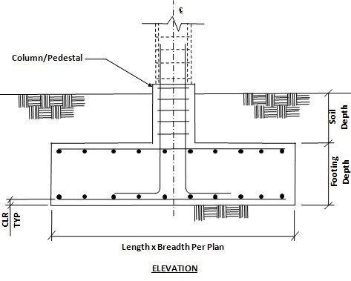

Figure 6(i). Schematic Elevation of Footing

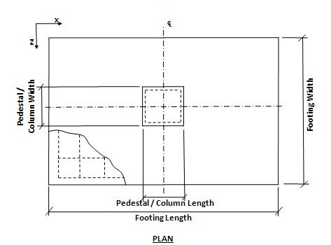

Figure 6(j). Schematic Plan of Footing

**7. SUMMARY OF** **AXIAL FORCES, SHEAR, TORSION, BENDING MOMENTS IN BEAMS AND COLUMNS:**

Column is a member supporting roof or floor system and predominantly subjected to compression. After analysing the structure prototype model for gravity load case the axial loads are find out at each storey level.

As point of view axial load important for design of column for gravity load (Dead Load and Imposed Load) so that it is necessary for finding out the convivence results. The maximum axial load are calculated in load envelope of load case are taken. The calculated result and STAAD results are tabulated.

The building is modelled in STAAD-pro software. After structural modelling the structure in STAAD Pro, the gravity load case analysis is carried out with above data provided.

Beam is a member predominantly designed for bending. Often itis also important to finding the bending moments for design purpose as the combination of axial force and bending moment is critical for force in column as axial loaded column, column subjected to uniaxial compression ‘and uniaxial bending & columns under axial compression and biaxial bending, For calculating bending force on column X and Y direction of plan is taken in STAAD as X and Z global axis. ‘The results are evaluated in post processing tab in envelope mode are taken as to finding out maximum bending moment and shear force. Bending moment and shear force is important for design of beams as these are critical force for design of beams. Are tabulated.

Axial Forces, Shear, Torsion, Bending Moments are tabulated Table below.

Table 7(a).

|  |  |  |  |  |  |  |  |  |  |
| --- | --- | --- | --- | --- | --- | --- | --- | --- | --- |
|  | | | | **Axial** | **Shear** | | **Torsion** | **Bending** | |
|  | **Beam** | **Node** | **L/C** | **Fx**  (kN) | **Fy**  (kN) | **Fz**  (kN) | **Mx**  (kNm) | **My**  (kNm) | **Mz**  (kNm) |
| Max Fx | 44 | 32 | 1:DL | 1.12E+3 | -1.923 | -0.953 | -0.003 | -0.914 | 1.963 |
| Min Fx | 175 | 70 | 2:LL | -6.350 | 39.188 | 0.035 | -0.064 | -0.078 | 50.382 |
| Max Fy | 217 | 86 | 2:LL | 18.659 | 41.014 | -0.047 | -0.214 | -0.007 | 53.357 |
| Min Fy | 235 | 85 | 2:LL | 16.461 | -39.594 | 0.085 | 0.423 | 0.180 | 50.554 |
| Max Fz | 94 | 66 | 2:LL | 72.966 | -0.716 | 14.119 | 0.049 | -18.729 | -0.695 |
| Min Fz | 106 | 78 | 2:LL | 72.966 | -0.716 | -14.119 | -0.049 | 18.729 | -0.695 |
| Max Mx | 249 | 144 | 1:DL | 0.056 | 7.422 | 0.000 | 1.109 | 0.000 | 0.000 |
| Min Mx | 246 | 138 | 1:DL | 0.056 | 7.422 | -0.000 | -1.109 | 0.000 | 0.000 |
| Max My | 94 | 82 | 2:LL | 72.966 | -0.716 | 14.119 | 0.049 | 28.570 | 1.705 |
| Min My | 106 | 94 | 2:LL | 72.966 | -0.716 | -14.119 | -0.049 | -28.570 | 1.705 |
| Max Mz | 217 | 86 | 2:LL | 18.659 | 41.014 | -0.047 | -0.214 | -0.007 | 53.357 |
| Min Mz | 217 | 141 | 2:LL | 18.659 | 16.014 | -0.047 | -0.214 | -0.146 | -38.853 |

**8. REINFORCEMENT IN COLUMNS AND BEAMS:**

After finding and tabulating the bending moment, reinforcement design are carried out in STAAD-pro gravity and. Horizontal member are assigned as beam and vertical members are assigned as column in STAAD-pro and IS 456 & IS 13920 used for

Designing the members and evaluating the output results by STAAD-pro. Design Parameter and command are assigned in STAAD pro then analysed. As the section are chosen for gravity load case it is only possible to design columns in STAAD-pro for Gravity & Wind load cases and below are the diagrams representing the design of beam and column.

**se**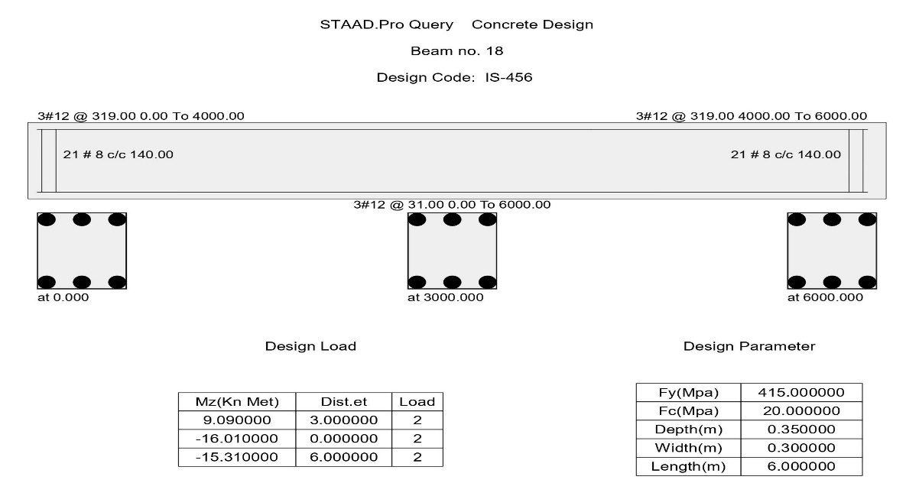

Figure 8(a). Beam Design

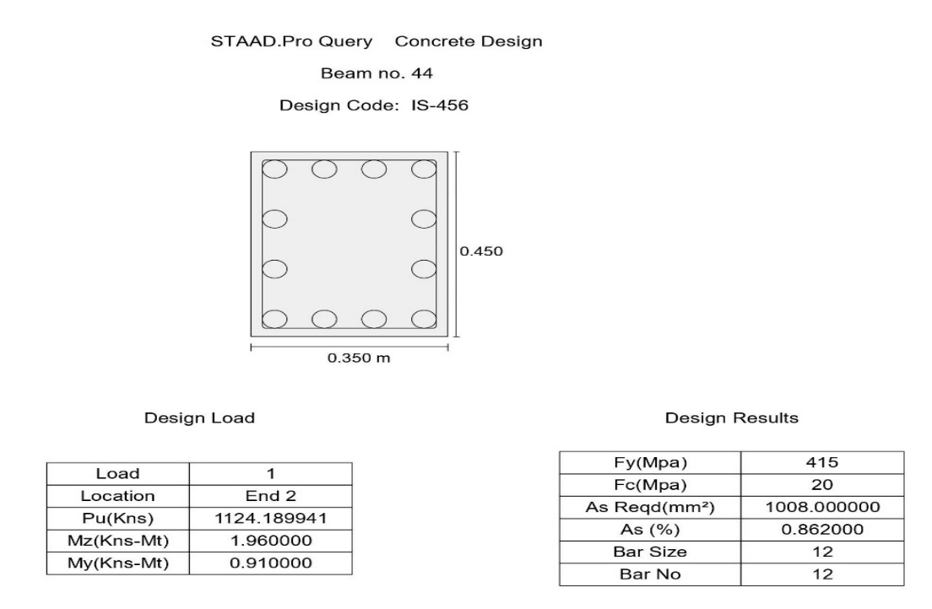

Figure 8(b). Column Design

**9. VOLUME OF CONCRETE AND STEEL IN SUPERSTRUCTURE:**

The total design volume of concrete and steel for superstructure can be found out by taking off concrete and steel in STAAD-pro.

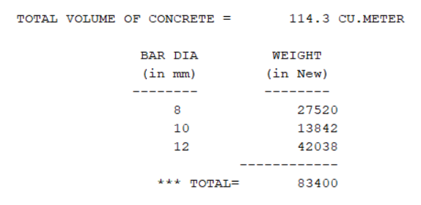

Figure 9(a). Total volume of concrete

**10. DESIGN OF STAIR CASE:**

The purpose of a stair case to provide access to pedestrian in a building. The geometrical forms of staircase may be quite different depending on the individual circumstances involved. The shape and structural arrangement of a staircase would generally depend on two main factors

Stairs consist of steps arranged in a series for purpose of giving access to different floors of a building. The location of stairs requires good and careful consideration. In the present design Dog-legged staircase is proposed. The dimensional details of breadth, length and height are 0.9m, 3.43 m, and 1.44 m respectively. Fig 10 shows the reinforcement detailing in staircase and the plan view of the staircase.

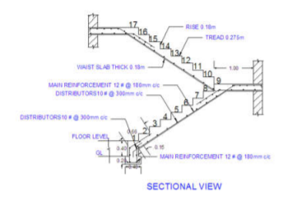

Figure 10

**11. CONCLUSION:**

* The structural elements of building are safe in flexure and shear.
* Quantity of steel provided for building is economical and adequate.
* Proposed sizes of structural elements can be used in building as it is.
* The design of beam, slab, column, footing and stair case are safe in deflection, bending, shear and other aspects.
* This project helps us understand the efficiency of software and how it eases our work with accurate results in minimum time.
* By the end of project, we have learnt the aspects to be considered for planning and achieved the aim of determining the reinforcement details and designing beams and columns which are capable to resists all the loads of the structure.
* By comparing the maximum shear force and bending moment in columns and beams it is found that STAAD pro result is more reliable than manual calculation.

**12. REFERENCES:**

1. Bedabrata Bhattacharjee & A.S.V.Nagender, Computer aided analysis and design of multi-storeyed buildings.

2. Arjun Sahu, Anurag Verma , Ankit Singh, Aryan Pal , Mohd. Shariq, Design & analysis of multistorey (G+3) residential building using STAAD.pro & AutoCAD.

3. Mr. K. Prabin Kumar, R. Sanjay Nath, A study on design of multi-storey residential buildings - a review.

4. Dunnala Lakshmi Anuja, V.S.Nagasai, Planning, Analysis and Design of Residential Building(G+5) By using STAAD Pro.

5. Shaikh Ibrahim, Md Arifuzzaman, Jisan Ali Mondal, Md Taukir Alam, Sanuwar Biswas, Sagar Biswas, Design and Analysis of Residential Building, International Research Journal of Engineering and Technology (IRJET), Volume: 06 Issue: 04 | Apr 2019.

6. Deevi Krishna Chaitanya, L. Santhosh Kumar, Analysis And Design Of A (G+6) Multi Storey Residential Building Using STAAD Pro., Anveshana’s International Journal Of Research In Engineering And Applied Sciences (AIJREAS), Volume 2, Issue 1 (2017, Jan), (Issn-2455-6300)

7. R. D. Deshpande, Manoj N. Pai, N. Pawan, Aashish P. Pednekar, Analysis, Design And Estimation Of Basement+g+2 Residential Building, International Research Journal of Engineering and Technology (IRJET), Volume: 04 Issue: 06 | June -2017.

8. D.R. Deshmukh, A.K. Yadav, S. N Supekar, A. B. Thakur, H. P Sonawane, I. M. Jain, “Analysis and Design of G+19 Storied Building Using STAAD-Pro”, Pg. 17-19, ISSN: 2248-9622, Vol. 6, Issue 7, (Part-1) July 2016

9. Aman, Manjunath Nalwadgi, Vishal T, Gajendra, “Analysis and design of the multistorey building by using STAAD Pro”, International Research Journal of Engineering and Technology (IRJET), Pg. 887-891, Volume: 03 Issue: 06, June-2016.

10. Mahesh Ram Patel, R.C. Singh, ”Analysis of a Tall Structure using STAAD Pro providing different Wind Intensities as per 875 Part-III”, International Journal of Engineering Sciences & Research Technology, Pg. 2018-2025, May, 2017.

11. Design of Reinforced concrete structure by S.Ramamrutham.

12. IS 456-2000 code book for design of beams, columns and slabs

13. SP-16 for design of columns.

14. IS CODE 875-1987 (Part 1,2 and 3).

15. BUILDING DESIGN AND CONSTRUCTION HANDBOOK (McGRAW-HILL)

**CARPET AREA OF THE BUILDING:**

Total area of the building = ***264.3 m2***

Office 1 = 16.25 m2

Office 2 = 16.25 m2

Conference Hall = 34.21 m2

Work Space = 34.21 m2

Cafeteria = 16.1 m2

Kitchen = 17 m2

Hall = 16.8 m2

Store Room = 16.42 m2

Corridor = 54.74 m2

Reception = 12.52 m2

Washrooms = 10.16 m2

Balcony = 14.3 m2

Froye = 5.34 m2